**Interpretations from Results:**

**Sample Result Set for Explanation:**

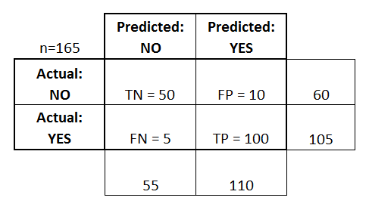

**Confusion Matrix Analysis for Test Data:**

|  |  |  |  |
| --- | --- | --- | --- |
| **N=16281** | **Predicted <= 50k** | **Predicted > = 50k** | **Total** |
| **Actual < = 50k** | 12226 | 209 | **12435** |
| **Actual > = 50k** | 3091 | 755 | **3846** |
| **Total** | **15317** | **964** | **16281** |

**Factors derived from the results:**

This is a list of rates that are often computed from a confusion matrix:

* **Accuracy:** Overall, how often is the classifier correct?
  + (TP+TN)/total = (12226+755)/16281= 0.79
* **Misclassification Rate:** Overall, how often is it wrong?
  + (FP+FN)/total = (3091+209)/16281 = 0.20
  + equivalent to 1 minus Accuracy
  + also known as "Error Rate"
* **Precision:** When it predicts yes, how often is it correct?
  + TP/predicted yes = 12226/12435 = 0.98